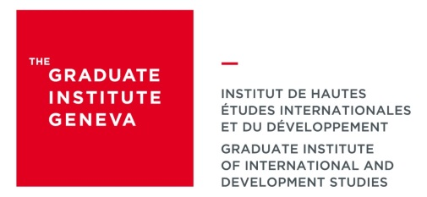
DPP in Conflict and Fragility Management

July/August 2019 – February 2020

To be completed by the organisation of the candidate

The DPP in Conflict and Fragility Management is aimed at working professionals at mid-career to senior career level, who hold or aspire to leadership positions in governments, international organisations and NGOs, as well as those in private sector seeking relevant skills and exposure.

The program helps them design and implement sound and sustainable development policies in conflict-affected or fragile regions. It provides strategic analysis tools in fragile settings and enhances the communication and leadership capacity of participants who apply newly-acquired skills through a professional thesis at work.

This document serves us as a basis to estimate the effects of the training on the graduates and their work. Thank you in advance for your collaboration!

Section 1 : DETAILS OF THE ORGANISATION
Name of the organisation

Contact person  Name  First name  Position | Telephone  Email

Section 2 : INFORMATION ABOUT THE CANDIDATE TO THE PROGRAMME
Name

First name

Position

Responsibilities

General appreciation of the candidate

Is a promotion of the candidate planned at the end of the programme?

Yes
No
Don’t know

Section 3 : INFORMATION ABOUT THE PROFESSIONAL THESIS
What is the relevance of the professional thesis and its possible use with regard to the activities and to the objectives of your organisation ?

THANK YOU!

